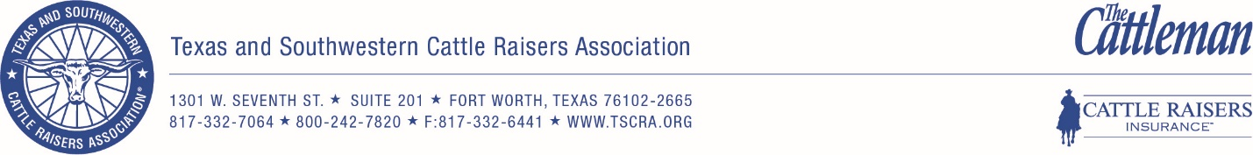

Young Cattlemen’s Conference Application

Biographical Background
Name TSCRA Member #
Address
City State _________________ Zip
Home phone Business phone
E-mail address
Birth date TSCRA Member Since
High School attended
College/University attended
Major area of study
Other educational experiences: (Graduate school, technical school, trade school, industry school, etc.)

Current employer:
Current job title:

Please indicate the industry segment(s) that best reflect your involvement in the cattle industry:
Cows: Stockers: Feeder Cattle: Allied Industry:

Have you ever attended a Young Leadership Series event? Yes No (Circle One)
Have you ever given the Young Leadership Series pitch at a TSCRA event? Yes No (Circle One)
Have you ever attended a TSCRA Convention? Yes No (Circle One)
Have you ever attended a TSCRA Summer Meeting or Policy Conference? Yes No (Circle One)
Do you currently serve on a TSCRA Committee? Yes No (Circle One)
Have you ever attended an NCBA Convention? Yes No (Circle One)
NCBA Member # NCBA Member Since:

Leadership Background (Please answer these questions in the space provided)
Describe your work history and how your professional career contributes to the beef industry.

Describe your current and past involvement in TSCRA activities.

How have you made a significant contribution to the cattle industry?

Describe your future intended/desired involvement in TSCRA activities.

Describe any public speaking experience that you have.

Describe any experiences you’ve had meeting with elected/public officials.

Other Community & Industry Organizations and Activities
Describe current and past involvement in community and industry organizations including leadership positions held, honors and awards received, examples of how your accomplishments have helped others, and any significant contributions you have made to the organization(s):

Provide an example of a team situation in which you were involved, and describe your role on the team:

What current legislative issue do you think is most important to the cattle industry and why?

What impact should TSCRA members have on NCBA policy and legislation and how can you fulfill that role for all members of TSCRA?

What would you do to lead and improve the TSCRA Young Leadership Series?

What would an ideal event and/or program for the Young Leadership Series include?

Why do you want to participate in YCC?

I hereby confirm that all information submitted in this application is accurate and truthful. If chosen, I commit to serving TSCRA’s Young Leadership Series in a leadership role for two years.

Applicant signature Date

Please return this application with two letters of recommendation to TSCRA by March 1, 2019.

